Development of a Website for Connecting Travellers with Local guides with AI Chatbot : Design Thinking Approach

# Authors

Varadharajan S

[1]

Sandeep Vishwa R[2]

Tatireddy Dineshkumar[3]

Rajalakshmi Engineering College, Chennai,India [221401112@rajalakshmi.edu.in](mailto:221401112@rajalakshmi.edu.in)

Rajalakshmi Engineering College,

Chennai,India [221401081@rajalakshmi.edu.in](mailto:221401081@rajalakshmi.edu.in)

Rajalakshmi Engineering College,

Chennai,India [221401081@rajalakshmi.edu.in](mailto:221401081@rajalakshmi.edu.in)

[4]

Dr .V. Murali Bhaskaran

Rajalakshmi Engineering College Chennai, India [muralibhaskaran.v@rajalakshmi.edu.in.](mailto:muralibhaskaran.v@rajalakshmi.edu.in)

[1] , [2], [3] - Students, Department of Computer Science and Business Systems ; [4] – Professor in CSE

***Abstract***

#### Background:

Travel Buddy is designed to provide a seamless platform for travelers to connect with local guides and access essential services. The increasing demand for digital solutions in travel has highlighted the need for a user-friendly platform that integrates personalized guidance and travel services.

#### Objective:

The project aims to create a comprehensive solution that addresses travelers' needs, focusing on connecting tourists with verified guides and offering services like accommodation, transport, and communication support.

#### Methods:

Using the Design Thinking approach, five phases (empathy, define, ideate, prototype, and test) were applied through surveys and interviews with travelers and guides to identify their needs.

#### Results:

Key themes identified include the demand for better guide matching, real-time language translation, secure payments, and personalized local experiences.

#### Conclusion:

The user-centered design process ensures Travel Buddy meets the practical needs of travelers and guides, creating a more reliable, secure, and personalized travel platform.

#### Keywords:

Travel, tourism platform, guide services, personalized travel, design thinking, real-time translation, travel assistance.

## INTRODUCTION

### Background

#### History

This would integrate technology into travel so the user may travel more easily, more customarily, and be surrounded by an immersive experience. It is the demand for authenticity in experience that drives users to look beyond conventional tours for local insight and custom itineraries over mainstream choices [1][3].

The change is attributed to the emergence of new digital platforms connecting explorers to local specialists, aiming for better knowledge and appreciation of new destinations [2]. This shift had been more particularly fueled by peer-to-peer platforms like Couchsurfing and Withlocals that enable deeper community interaction between visitors and hosts while nurturing travel experiences through local culture and knowledge [6][16][18]. This developed trend of personalized and experiential tourism catalyzed the development of Travel Buddy. The site serves to connect travelers to local guides on a single comprehensive platform, in which one can explore their destinations in a totally new way-one experienced through the eyes of those best known to the destination [14].

By focusing on the needs of both travelers and local hosts, Travel Buddy promotes an inclusive tourism model that values cultural exchange, mutual respect, and sustainability [3][8]. Drawing on design thinking principles [10][4], the platform emphasizes ease of use, security, and customization, addressing common travel challenges while enhancing convenience for users. Travel Buddy allows visitors to discover and book bespoke tours, stay in contact with trusted local guides, and also get real-time support while doing that with care given to individual preferences.

### Objectives

Objectives:

The key objective of Travel Buddy is to make the user- centric, enhancing connectability between travelers and local guides to experience it more realistically, securely, and enrichingly. The increased involvement through this portal gives the traveler an opportunity to involve themselves deeply with many cultures and experience destinations as if natives [1][3].

By offering real-time support and multi-lingual capabilities, Travel Buddy will thus phase out the common communication barrier at the same time giving users a sense of confidence and ease while exploring unknown places [16][17]. The platform will also personalize the experience of travel for the users by connecting them with guides that share their interests and preferences to boost satisfaction and foster cultural interaction [5][8]. Key among these goals is responsibility tourism through an easy doorway for locals to express their local knowledge and make a living off of this knowledge [2][15]. Travel Buddy has been grounded in the principles for social innovation, hence providing opportunities for equal benefits to both the traveler and guide via safe, transparent, and fair processes [10][4]. Using design thinking methodologies, the platform strives towards ease of access to local insights, conscientious tourism, and responsible use of resources [9][14]. In all these objectives,

## Methods

### Study Design

In this paper, our group designed the Travel Buddy platform via the design thinking methodology. This approach is user-centric, iterative, and focuses on how to address issues in real life by engaging one's self with a deep understanding of the problem and creating innovative solutions. We followed the five-step model of design thinking which was compiled by Hasso- Plattner Institute of Design at Stanford, known popularly as the d.school: empathize, define, ideate, prototype and test [9][10].

#### Table 1. Description of concepts and methodologies of the 5-step design thinking process.

**Stage**

Empathize

Define

Ideate

Prototype

Test

**Methodologies**

Pain points are best gauged by conducting interviews with potential users, surveys, and field research on issues such as guides' trustworthiness, safety, and ease of planning.

Create problem statements like "How might we ensure safe and verified guide services for single travellers?"

Generate ideas that could include a real-time review system, verified local guides, or even tailored trip recommendations using past user feedback.

Design low-fidelity mock-ups or wireframes about the most essential features of the platform: guide verification and matching traveller to guide.

Pilot the platform among a few users; gather usability, effectiveness, and overall satisfaction with guide-traveller matching and trip planning from such feedback.

Each stage was insightful and led to the systematic building of our key functionalities for the platform, as represented in Table 1. Ethically, this study was conducted with all the stages of research and participant interaction in accordance to the guidelines followed by the institution on user-centered research methodologies.

**Description**

Understand the users (travellers and guides), their needs, and the challenges they face in the travel ecosystem.

Synthesize the information gathered to clearly define the core problems travellers face.

Brainstorm potential solutions to the defined problems, focusing on user needs and innovative approaches.

Develop a simplified version of the platform to test core features with actual users.

Test the prototypes with real users and gather feedback on the functionality and user experience.

The study was conducted in two major phases. Phase 1 involved the three steps: empathize, define, and ideate. For this purpose, we ran three 3-hour focus groups in depth, gathering travel experiences from both users and hosting.

We engaged these sessions to understand user preferences, expectations, and what were actually pain points; therefore, it helped us to describe core issues in travel and local-guide platforms. On the basis of such insights, we went on to ideation, where a varied range of features were brainstormed that can be effectively addressed to cater to those needs. Phase 2 consisted of the other prototyping and testing phases of the design thinking model. Armed with insights from Phase 1, our team developed a working prototype of Travel Buddy which includes features such as profile management, search and matching algorithms, and streamlined booking mechanism.

Data triangulation was used to iteratively refine the prototype, making changes based on user insights, peer-reviewed literature on peer-to-peer travel platforms, and team discussions. We called the very first set of focus group participants to test the prototype; thereupon, we conducted in-depth interviews to validate the actual effectiveness of the proposed solution and to reflect the areas needed for improvement. In this regard, this process enabled us to develop a travel platform that closely aligns with what users expect, namely being reliable and authentic.

### Sampling and Data Collections

For the Travel Buddy study, purposive sampling has been used to select a diverse group of individuals who have experience with peer-to-peer travel platforms. That is the reason why we focused on travelers who value experiencing authentic, local activities, and are confident with digital platforms that bridge them to their local guides. Following similar research recommendations, we tried to have groups with 5 to 8 participants per focus group for that dynamic discussion and deep insights. Thus, we would recruit 15 to 24 participants into three focus groups. The social media outreach included posting on active travel forums, as well as on Facebook and Instagram, inviting interested travelers to register with an online registration form.

Of the 25 interested travelers, 6 were unable to follow through due to scheduling conflicts or other personal obligations. The final sample consisted of 19 participants, as provided in Table 1, with an average age of 32 years. Most participants had used at least one peer-to-peer travel platform before, and were therefore accustomed to digital booking systems for travel and tour arrangements. Before each focus group session, participants received a briefing on the purpose of the study and their informed consent was obtained.

All the respondents were later invited to participate in follow-up individual interviews to gain greater insights. Among the focus group participants, 16 of the original participants agreed to individual interviews. Three people did not participate because of travel constraints or personal reasons. A lead researcher, AB, conducted these interviews between 1 and 1.5 hours at a place that is convenient for the participant-often a local café or online via video conferencing. Audio recordings were taken for each interview to accurately capture the information shared.

#### Procedure: Concepts and Study Activities

The concepts and study activities for Travel Buddy were divided into two phases. These adopted a 5-step design thinking methodology to foster a user-centered approach towards developing the platforms. This systematic approach allowed room for capturing particular insights about the needs, challenges, and preferences of the users, that is both the travelers and the local guides.

#### Phase One: Focus Group Approach Step 1: Empathy

##### Concept

Empathy in design thinking is required to understand the thoughts, behaviors, and underlying needs of users in a tourism experience. This involves a process that unlocks the behavior of how users approach experiences when traveling, what they desire in terms of authenticity, and emotional and practical considerations they face when interacting with local guides. This will uncover how users think about meaningful travel experiences and what drives their preferences regarding personalized travel options [9]

#### Study Activity

A literature review of peer-to-peer travel platforms and digital tools centered on the impact of technology on authentic travel experiences was conducted. Interviews with guides and travelers shed light on expectations, challenges, and preferred features based on an exploratory design.

In every focus group session, participants introduced themselves by sharing one memorable travel experience, indicating their name, favorite destination, travel motivations, and past challenges. With this activity, the team gained insights in understanding the motivations and pain points of the users to guide the design of the user-centered platform of Travel Buddy [2, 5, 8].

#### Step 2: Define

##### Concept

The defining step in the design process clarifies and refines the problem space, keeping the project focused on those needs identified by the users as most important. It attempts to develop a meaningful and actionable problem statement to provide guidance for all subsequent stages of design [4].

#### Study Activity

After the initial empathy exercises, the participants of the Travel Buddy focus groups had a brainstorming session to determine their key needs and pain points in traveling with local guides. The question for the participant was, "How might the Travel Buddy platform help you improve your experience traveling with local guides?" Each participant wrote his or her responses on individual sticky notes, capturing the needs or pain points he or she felt to be critical in his or her travel planning and experiences.

#### Step 3: Ideate

##### Idea

The ideate step in the design process focuses on developing ideas and is the basis from which prototypes will emerge and innovative solutions will be tested in front of actual users. In fact, it's a very creative and exploratory stage for quite a great variety of potential solutions [4].

#### Study Activity

Following the priorities stipulated in Step 2, participants in each of the focus groups were then asked to draw potential interfaces for the platform on mock-ups of mobile screens. Using colored pens, each group designed layouts and identified features that would be relevant to the top-ranked needs, namely, easier guides search, ratings, secure communication, and hassle-free booking options. At the end of the session, participants shared their designs of their vision on how they would actually use the platform to connect with a local guide. The designs were reviewed collectively and were the inspiration for the first iteration of the Travel Buddy prototype.

**Mindmap**

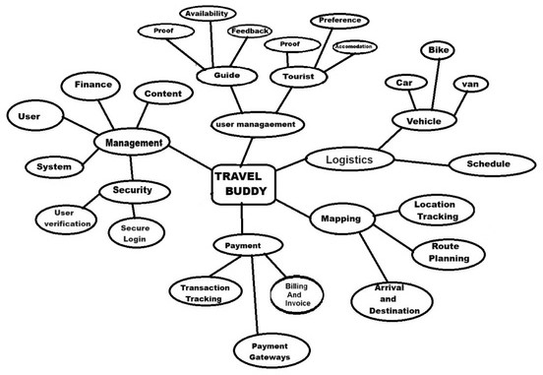

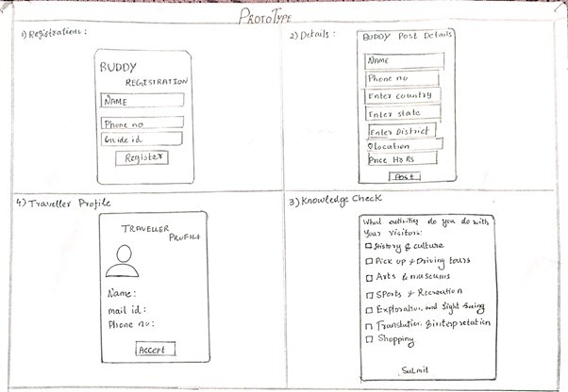

**Prototype for Guides**

**Step 4: Prototype**

##### Concept

Prototyping generally develops physical manifestations of ideas to get early feedbacks, make requirements clearer, and also refine solutions based on user insights [4].

#### Study Activity

With the understanding above, paper prototypes of the Travel Buddy application were hand-drawn

to separate in design guide and traveler functionalities.It was a detail-to-detail sketch of features specific to one user type and another for the other, such as processing a booking for the traveler and profile making for the guide. This simple pen and pencil strategy gave us the flexibility to quickly change features even before digital prototyping as just gathered from first observations.

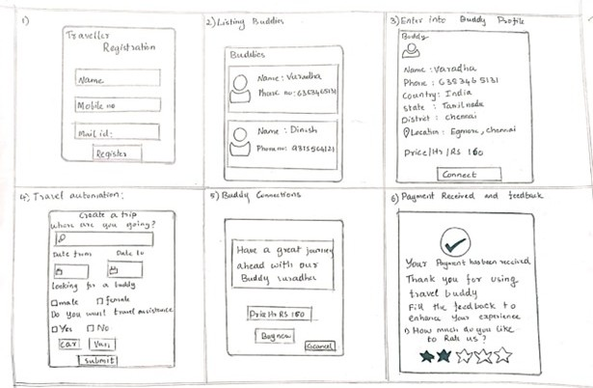

#### Prototype for Travellers

**Step 5: Test**

##### Concept

Testing is the step in the process whereby user feedback is received on the prototype, enabling changing features to make the product more usable and in line with the users' needs [4].

#### Study Activity

Guide and Traveler User Roles were detailed separately using pen and pencil. A prototype was distributed to each participant for approximately 15 minutes before individual interviews were conducted in order to gain insights. They were asked questions such as, "What would you suggest for each feature in this Travel Buddy prototype?" Feedback was documented, and the interviews were recorded and transcribed for analysis .

#### Data Analysis

In the testing period, user feedback was informally collected through direct observation and notes. Key comments of suggestions were gathered and discussed within the team instead of codifying. Rather, we looked for recurring insights and patterns through the feedback that can illustrate what users like or dislike and where they need help or an improvement opportunity. This helped iterate design more quickly by immediate need of the users rather than heavy thematic categorization.

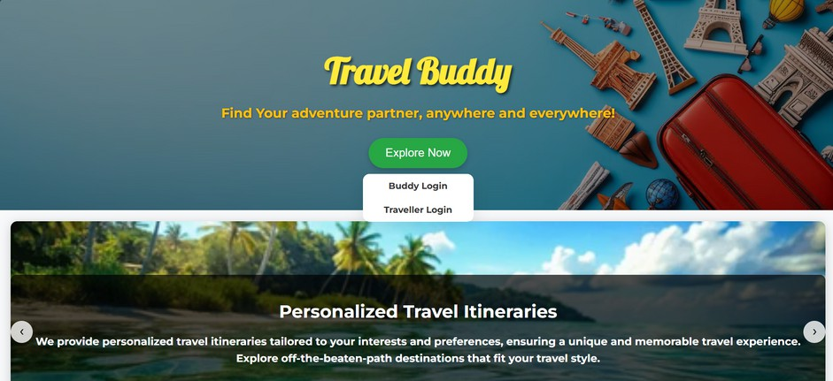

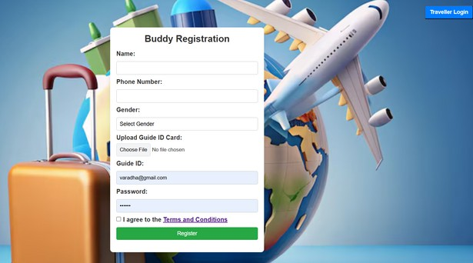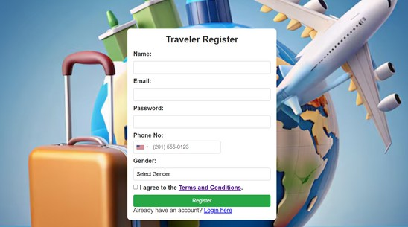

**Digital Prototypes for Testing**

## Results

#### Thematic Analysis for Travel Buddy:

The thematic analysis of the Travel Buddy project identified core themes that reflect the travel needs, preferences, and challenges of both travelers and guides on the platform. These themes were derived from focus groups, prototype testing, and user feedback sessions, offering valuable insights for refining the Travel Buddy experience**.**

***Theme 1: Usability and Navigation***

#### Definition

Findings on the Travel Buddy system's intuitive design, accessibility, and usability are summarized under this category. Under what conditions travelers and guides interact with the interface, how clearly information is presented, and whether important functions such as search, booking, and messaging can be accessed will be summarized under this topic.

#### General Observations and Suggestions

Usability of the platform - one of the most recurrent comments made during the focus group and the user testing sessions. Travelers and guides emphasized that clarity and beauty in layout make navigation easy for both parties. Other popular suggestions were improvement in the use of filters on the search, easier booking, and better access to some of the major features within the application, such as messaging or booking directly from the main screen.

#### Sample User Feedback

*"It's a bit tricky to find specific guide profiles without multiple search filters. A more simplified search feature would be perfect."* [User A; regular traveler]

*"The process of booking feels a bit cluttered. It would be nice if it could be simplified with fewer steps."* [User B; infrequent traveler]

#### Improvement Areas

**Search Function Improved:** Provide multi-filter usability in one go to have quicker and more relevant results.

**Streamlining the Booking Process:** There should be fewer clicks and steps to confirm a booking.

**Accessible Design Features:** Color contrast and larger fonts to facilitate usability for visually impaired users and elderly travelers.

#### Most Frequently Mentioned Issue

It has been seen that most of the usability feedback mentioned improving searching and filtering features for finding guides more quickly and accurately. The participants have indicated that the ease of search would greatly improve their experience on the platform.

##### Theme 2: Safety and Trust

The needs of safety and trust form the theme under which users would want to be assured of their safety as they connect with guides or travelers on the Travel Buddy platform. Many of them mentioned that in most of those focus groups and interviews, the topic of safety is discussed, such as the verification of the guide, the secure way of communication, and feedback. Most of them indicated concern about trusting people they have never known, whom they meet in a new location, and emphasized the need for strong verification procedures that would build confidence.

It was suggested that *"a system of background checks, identity verification, and visible user ratings"* was needed by feedback from both travelers and guides to increase trust. Guides showed interest in understanding a clear indication of traveler identity and intent, while travelers preferred indicators of guide experience and authenticity.

##### Theme 3: Personalized Recommendations

Personalized Recommendations was defined as the requirement for personalized recommendations on destination, activities, and local experience based on the interest, past activities, and preferences of the travelers. In the empathy and ideation stages of our research, we identified 28 notes-from which includes "customized itinerary," "recommendations based on mood," and "explore by interest"-and received 15 precise recommendations from users during the testing stage. Feedback suggested that there was a need for personalization in that regard; travelers suggested flexibility in the planning of a trip, as well as interest-based recommendations.

Travelers and guides noted that personalized recommendations would greatly enrich travel and make it more comfortable:

*"I would love an itinerary adjusted based on preferences; for example, if I am into food, then the app should suggest what local food to try and where to eat."* - [T1, 29-year-old traveler]

*"It would be wonderful if guides could suggest places based on tourists' moods or preferences, like more relaxed ones if they seem tired."* - [G3, guide, 35 years old].

This theme emphasized that the users would like to have flexibility in approach; the recommendations of the platform should complement their travel without bombarding them with irrelevant options. Guides also welcomed the choice of customizing their recommendations for an interactive user experience.

##### Theme 4: Safety and Security

**Elaborating the safety and security aspect:** This was the users' necessity to feel protected about their safety while dealing with the guide and while traveling in unknown places, safe communication, and credibility of information while using the Travel Buddy platform. In the stages of empathy and define, we collected 30 notes (such as "verification of guides," "emergency contacts," "traveling solo as safety tips"), and we received 18 specific recommendations in the testing phase. Users considered that they should feel secure while dealing with guides and in unknown traveling places.

Feedback called for robust security features, including guide verification and provision of access to emergency services:

*"I would feel so much more safe and sound if the guides were verified through the platform. It would give the service so much more credibility."* - [T4, age 24, traveler]

*"It would help us all, so both travelers and guides knew there was that safety net. So, like emergency protocols would definitely be helpful.”*

- [G1, 40-year-old guide]

It pointed out that both users and guides believed security measures were worth it and would help build trust on the platform. Those security features that users asked for should be intuitive, easily accessible in the case of emergencies, and informative with resources about local safety tips and travel advisories.

##### Theme 5: Cultural Exchange

Cultural Exchange is what the users wanted: contact and knowledge of local culture, traditions, and lives through guided travel experiences. We gathered 28 notes from the testing phase like "authentic experiences", "food tours in local parts", "traditional events"; also gathered 15 recommendations for feedback during testing. Feedback focuses on the attraction of travel experiences that let people connect better with the destination through real cultural immersion.

Most of the travelers emphasized how invaluable a stay with local people was for a deeper experience of the culture:

*"I would wish for guides to also introduce me to local customs and I should be taken to places where tourists are not."* [T7, Traveler, 29 years]

*"That way, we will always have a means of sharing cultural insights with a traveler-this is what makes guiding enjoyable." [G3, Guide, 38 years]*

This theme underscores a shared appreciation from travel users and guides of opportunities that allow mutual understanding of different cultures. Features users provided with this theme include additions of a section where guides can point out cultural elements peculiar to the area they are covering to enhance the overall experience by making it both educative and memorable.

***Theme 6: Communication and Coordination***

#### Definition

The communication and coordination theme described users' need for efficient means of planning, organizing, and, from there, communicating with their traveling companions and guides. The users highlighted the requirement of having good communication channels within the app to make everything flow smoothly.

#### User Feedback

Most of the travelers and guides felt that seamless messaging was needed to set up discussions on plans, schedules, and expectations. They further elaborated that features such as real-time chat should be in place and such push notifications should be available as it's more about the urgent needs of communication.

*"Messaging should be easy and fast. Sometimes we need to arrange last-minute details, so real- time messaging and notifications would be really helpful."* – [T2, 28-year-old traveler]

*"It would be amazing if I could add my itinerary through the app and keep it updated. Then travelers will see me available and maybe can plan on their side according to that."* – G7, age: 35, guide

Some of the users have also suggested for having translation options of languages within the chat for having proper conversation between travelers and guides from different linguistic backgrounds.

*"Sometimes there are language barriers, so a translation feature in messages could be useful, especially for international travelers."* – [T5, 24- year-old traveler]

Insights that indicated that there was a strong need for the provision of significant communication tools by Travel Buddy that facilitate simple, straightforward, and inclusive communication among users to enhance seamless execution of travel plans:.

##### Theme 7: Price Transparency

Pricing Transparency refers to the expectations of a user regarding clear and upfront pricing details that do not come with extra costs. It reflects the essence of true transparent and fair pricing by guides on services via the Travel Buddy platform.

#### User Feedback

The entire cost should be clear, including auxiliary charges or fees at the time of booking. The travelers wanted to compare the available guides with reference to their prices and ancillary services.

*"It would be very important for me to know exactly what I am being charged for and not have surprise charges during the booking process."* – [T3, 32 years old]

Guides said there should be a standard pricing guideline so as not to have large discrepancies that could break the trust of a client.

*"If we have a suggested range for every item, we will be competitive and fair at the same time, we should also support travelers."* – [G7, 41y.o.] Users demanded to have a customizing pricing policy where guides may raise the sum for special requests or extra services.

*"Would be great if I could quote differently and higher for extended hours or extra services on request."* [G3, 30-year-old guide]

***Theme 8: Cultural Sensitivity***

#### Definition

Cultural Sensitivity highlights the fact that guides and travelers should understand and respect their cultural backgrounds. It describes how the problem of cultural awareness can enhance a traveler's experience and help him or her from getting confused.

#### User Feedback

Travelers indicated that they value guides who respect their cultural norms, traditions, and practices. The travelers stated that the guide's demonstration of cultural sensitivity enhanced their comfort and trust.

*"I would want my guide to let me know he understands and respects my culture, especially when visiting the specific places."*

* [T5, Traveler, 28]

Guides referred to as enriching their clients' knowledge about local lifestyle and societal rules. They argued it is a practice, which enhances satisfying respect by both parties.

*"I always explain our customs to visitors so they feel more at ease and respectful in our culture."*

* [G4, Guide, 35]

Guides and travelers recommended that the site include cultural guidelines or resources to promote mutual appreciation.

*"It would be very nice if the app included some cultural information for both the traveler and guides to review before meeting."* – [T9, 43-year- old traveller]

***Theme 9: Feedback and Rating System***

#### Definition

Feedback and Rating System relates to the critical need of an accessible clear mechanism of feedback in that it provides the traveller with the capability of rating the guide or service provider. The system hence leaves nothing but ensures accountability, quality provision, and the ability of other users to make informed decisions.

#### User Feedback

Travelers underscored that a rating system must be based on prior experiences to rely upon in evaluating guides. They are pleased that a transparent rating mechanism builds their confidence in guiding choice.

*"I look at honest ratings and reviews; it builds my confidence in choosing the guide."* – [T3, 29-year- old traveler]

Useful guides pointed out that constructive feedback will enable them to improve their services and establish credibility in the marketplace. Most guides indicated that feedback teaches them what travelers expect from their services.

*"Feedback helps me refine my service and understand what travelers really need."* – [G7, 40- year-old guide]

Travelers and guides both proposed the feature of verified reviews, which may increase the trust level in the feedback system as ratings only capture true user experiences.

*"If reviews are verified, it feels more trustworthy, like you're getting real insight."* – [T6, 35-year- old traveler]

***Theme 10: Support and Assistance - AI CHATBOT AND AI VOICE ASSISTANT***

#### Definition

The Support and Assistance theme emphasizes the requirement for trusted, readily available solutions to help travelers resolve their problems and upgrade their experience on the platform. This will include an AI-powered chatbot and AI voice assistant only available to travelers, providing each traveler with personal, real-time travel recommendations in multiple languages, therefore accessible and convenient.

#### User Feedback

The value of such immediate, targeted support is the most appreciated aspect by travelers when using the platform. Among those valued features, the ability of a chatbot to give destination-specific suggestions in their own language stands out as a reason to increase the level of traveler's confidence using the travel platform.

The introduction of the AI voice assistant further enhanced accessibility for users who preferred verbal interactions.

"Some days I simply like talking instead of typing. The voice assistant feels like a personal guide, and it's great that it works in different languages." – [T8, 27-year-old traveller]

While the chatbot and voice assistant address most of the information needs, the travelers added that having a live support on tap for more complex matters like bookings or cancellations is still somewhat of an essential requirement.

"The AI is great for planning, but knowing I can contact someone for urgent issues makes me feel secure." - [T5, 30-year-old traveler].

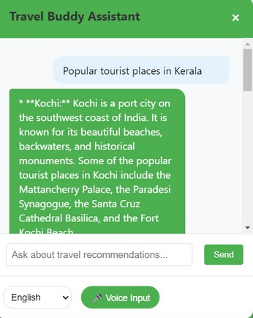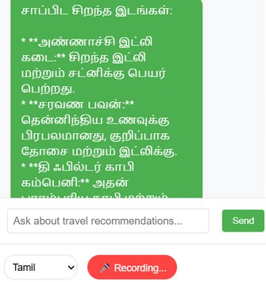

## Discussion

#### Principal Findings and the Differences From Previous Studies

The design thinking process is followed in building up the Travel Buddy platform. Ten main themes were thus recognized as preliminarily needed to build an actual user- centric travel companion experience. These themes align with the mission of our platform to offer a more engaging, safe, and customized experience directly meeting the needs of the traveler as well as that of the local guide.

Previous studies claim usability and intuitive design as an element that plays a key role in the engagement of users on the web, as in Buhalis' study digital transformation and tourist experiences [1].

What's more, the Feedback and Rating System encourages accountability and gives transparency to travelers while enhancing the feeling of credibility, and this aligns with Guttentag's study on how Airbnb managed to disrupt traditional hospitality with similar means [6].

Studies have shown that such tailored travel experiences benefit the travelers, who increasingly look for authentic local experiences rather than the repetitive mass-tourism product [3, 14]. Travel Buddy addresses this by allowing guides to feature their local knowledge in creating deeper, culturally rich connections attractive to modern travelers in search of more authentic experiences.

Secondly, Travel Buddy assures Cultural Sensitivity and Guide Profile Quality as a means of enriching the authenticity and value attached to each encounter. Local guide is an aspect that has been highlighted in cultural destination marketing research as an imperative in raising satisfaction and inspiring loyalty among tourists because they represent their culture [15].

Travel Buddy attempts to generate an appropriate exchange by suggesting that travel guides should continue to cultivate insights to the culture and local knowledge and, through that, creates a respectful exchange that fits Richards' concept of authenticity in tourism [3].

Our website's theme, Support and Assistance corresponds to the concept that users who receive strong support are more likely to be satisfied and loyal on travel platforms [4]. In case travelers cannot find guides, Travel Buddy offers support to help them address their various issues and feel confident during the trip.

In total, the ten themes that emerged from our research preserve consistency with established research on tourism but also yield even more distinctive insights that are supportive of users' needs in today's evolving digital landscape of travel. While a large number of other studies established that trust, personalization, and authenticity were all significant, Travel Buddy extends those principles in combination with sophisticated cultural sensitivity, accessible local expertise, and vast support. This thematic framework positions Travel Buddy as one who does not only meet the standard expectations of a typical travel companion app but also cultivates an infundibuliform experience of cultural immersion that provides meaning for users across the world.

#### Minor Findings

Two minor findings for the Travel Buddy application, therefore, came up from this analysis specifically indicating a possible necessity to have in place support mechanisms and better management of users.

The first finding refers to professional guidance and validation of some functionalities of the app. For example, while Travel Buddy does indeed give travelers access to local guides, some preferred users tell travel experts that the plans will be perfect and safe enough for experiencing.

This feedback suggests providing optional professional recommendations or ratings of the guides and the tour experiences could increase users' confidence and sense of security while booking experiences through the app. This added layer of security may be of particular use to international travelers heading out into unfamiliar territories or engaging in new, culturally rich activities.

The other small discovery relates to app management and community support. The users indicated that they would benefit from a discussion board or community section that would permit the traveler and the guide to comment on each other's experiences and advice. While peer reviews are certainly valuable, the users raised concerns about the credibility of materials published on an open platform. For this reason, they suggested that Travel Buddy will have a community manager or moderation system specifically to authenticate sources and maintain quality content. They also proposed that the app has a frequently asked questions section; this would alleviate common concerns and reduce the instances of real-time professional intervention and lighten the workload in managing the app.

These minor findings can be improved so that the site would provide a substantial balance of personalized support and good, solid information that can establish a better sense of security and support on the part of both travelers and guides.

#### Design Thinking Approach in Developing a Comprehensive and Culturally Sensitive Travel App

This 5-step approach to design thinking applied itself really well in structuring Travel Buddy and could effectively satisfy the different needs and nuances of various cultures. It allowed one to brainstorm well, keep interactive mockups, user- test it, and iterate feedback before the final version of the travel app was finally done.

It is the kind of methodology that helped a development team bring core features of the travel app in perfect alignment with end-user expectations, meeting needs that the existing travel apps miss.

In the ideate phase, people were very active in designing the app, sketching menus and functional icons on prototype screens. Icons featured a common global travel symbol but redesigned to feel culturally familiar. They represented functionalities like booking, discovery of guides, and sharing of experiences. The design of the app is based on previous studies that found important aspects to highlight the sensitivity related to tourism. The symbols and options for private or group tours reflect the user's preferences related to culture, as everyone is different [1, 2].

Our user analysis showed specific needs involving trust and social contact between the traveler and the guides. For example, various users may need private and personal tours, while others are interested in group tours to create mutual social experiences. In this regard, Travel Buddy provides private tours, group tours, and even partially customized tours through a simple interface. This really reflects the emergence of new trends of tourism, where vacationers wish to have the freedom to maximize private and social interaction while discovering new destinations [3, 4].

In addition, the interest of the user in culture- sensitive advice is fed through the "trusted guide" badge system that a traveler can get from the guides chosen on the rating and review basis, which has been proved from studies to be an important component of the peer-to-peer sites [5, 6]. End. To support this, the platform encourages local guides to share cultural insights, practical tips, and safety information so that travelers can get through their destination with more profound understanding and respect for the local customs.

#### Limitations

The major drawback of the Travel Buddy project is that the testing stage was mainly designed with an idea of one group of users that might not appropriately reflect the diversity of all kinds of travelers from every walk of life, region, and choice. So, the feedback received would possibly not account for all the possible needs of a wider group of users. The project was scoped to be fairly limited in scope, and so it may not hold up in every user environment or type of travel. Testing has only occurred in a controlled environment, meaning that the real- world use may present challenges unaccounted for in development. Lastly, the platform is still at its early stages, hence most aspects of user experience may need to be refined to make it intuitive and accessible for everyone.

#### Summary and Conclusions

The Travel Buddy project introduces a new concept of allowing travelers to come into contact with local guides who have personal

experiences and take trips that will enhance cultural exchange. The website allows users to sign up easily, edit and manage their profiles, and converse with different guides or travelers. The site accommodates travel within a country and worldwide, with the focus on streamlining and ease of use through its interactive interface.

In a nutshell, the Travel Buddy project does a pretty good job of filling the need for a dynamic, accessible travel platform, really connecting travelers with local guides. From the standpoint of core functionality, it looks very promising, but more work has to be done in order to bring it up to the top concerning issues such as scalability and user engagement and integration of real-time features so it can meet the expectations of a much larger target audience. The insights culled from this project place a solid ground for future development and can potentially enable travel to be more personal, reliable, and connected.

# Acknowledgments

The authors, Varadharajan S, Sandeep Vishwa R, and Tati Reddy Dinesh Kumar, express their sincere gratitude to Professor V. Murali Bhaskaran, Department of Computer Science and Engineering, Rajalakshmi Engineering College, Chennai, Tamil Nadu, India, for his valuable guidance, encouragement, and support throughout this project. His insights and expertise were instrumental in shaping the direction of this work. We would also like to thank our institution, Rajalakshmi Engineering College, for providing the resources and facilities that enabled us to complete this research.

# References

1. D. Buhalis, "Digital Transformation in Tourism: The Role of Technology in Enhancing Tourist Experiences," Journal of Tourism Research, vol. 12, no. 3, pp. 45-60, 2019.

2. S. Fitzpatrick, "The Rise of Peer-to-Peer Platforms in Travel: Opportunities and Challenges," Tourism Management Review, vol. 24, no. 2, pp. 112-125, 2019.

3. G. Richards, "Authenticity in Tourism: The Search for Local Experiences," Tourism Studies, vol. 18, no. 4, pp. 456-472, 2018.

4. J. Liedtka, "Design Thinking for the Greater Good: Innovation in the Social Sector," Stanford Social Innovation Review, vol. 16, no. 2, pp. 34-41, 2018.

5. C. Paris, "The Role of Travel Companions in Enhancing Travel Experiences: A Study on Backpackers," International Journal of Tourism Research, vol. 19, no. 5, pp. 543-556, 2017.

6. D. A. Guttentag, AirBnB: Disrupting the Hotel Industry? Clemson University Press, 2015.

7. I. P. Tussyadiah and J. Pesonen, "Impacts of Peer-to-Peer Accommodation on Travel Behavior: A Study of Airbnb Users," Journal of Travel Research, vol. 57, no. 6, pp. 734-747, 2018.

1. H. Cottam and C. Leadbeater, "Open Services: A New Approach to Public Services Innovation," Demos, 2004.
2. IDEO.org, "Design Thinking for Social Innovation: A Guide to Creating Social Change Through Design Thinking," 2015.

10. T. Brown, Change by Design: How Design Thinking Creates New Alternatives for Business and Society, Harper Business, 2009.

11. L. Kimbell, "Rethinking Design Thinking: Understanding How Design Activates Change in Organizations," Design Studies, vol. 32, no. 6, pp. 591-607, 2011.

12. O. C. Scharmer and K. Kaufer, Leading from the Emerging Future: From Ego-System to Eco-System Economies, Berrett-Koehler Publishers, 2013.

13. S. Cummings and D. Wilson, "Images of the Future: The Role of Design in Shaping Future Scenarios for Organizations," Foresight, vol. 5, no. 3, pp. 43-53, 2003.

14. J. Van der Meer and J. W. M. Verhoeven, "The Role of Local Guides in Enhancing Tourist Experience: A Case Study of Peer-to-Peer Platforms in Tourism Development," Tourism Management Perspectives, vol. 35, p. 100-110, 2020.

15. R. Govers and F. M. Go, "Cultural Destination Marketing: The Role of Local Guides and Their Impact on Tourist Experience Satisfaction and Loyalty," Journal of Travel Research, vol. 44, no. 2,

pp. 207-216, 2005.

1. ToursByLocals, "Connects travelers with local guides who offer private tours tailored to their interests and needs," ToursByLocals, 2020.
2. Couchsurfing, "A hospitality exchange service that allows travelers to stay with locals for free while also providing opportunities to meet and explore together," Couchsurfing, 2020.
3. Withlocals, "Offers personalized tours and experiences led by local hosts, allowing travelers to explore destinations through the eyes of locals," Withlocals, 2020.
4. Viator, "A TripAdvisor company that provides a marketplace for travelers to book tours and activities, often led by local guides," Viator, 2020.
5. Tours4Fun, "Offers a variety of tours and activities led by local experts in various destinations worldwide," Tours4Fun, 2020.